Images exported from Sangala Blocks "Crane".
Step 1
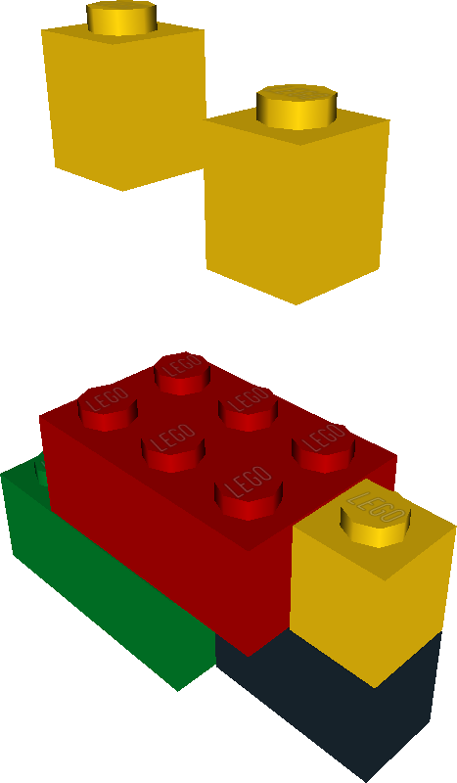

Step 2


